XXX System
Version XX

Testing Report

Class：
Team Member：
Document Version：
Date：

Content
Content 2
1 Introduction 3
1.1Objective 3
1.2References 3
1.3Testing Plan 3
2Testing Results 3
2.1 Test Cases for Method1 3
2.2 Test Cases for Method2 3
2.3 Test Cases for Method2 4
3 Results Analysis and Suggestions. 4

1 Introduction

1.1Objective
The main purpose of this project is to detect the possible uncovered errors and analysis the values.

1.2References
1. Dr. Zhu Ming, "Software Engineering Course", Shandong University of Technology, 2nd September, 2021.

1.3Testing Plan

1.3.1 Structural testing

Basis path coverage
- Custom Power function structure
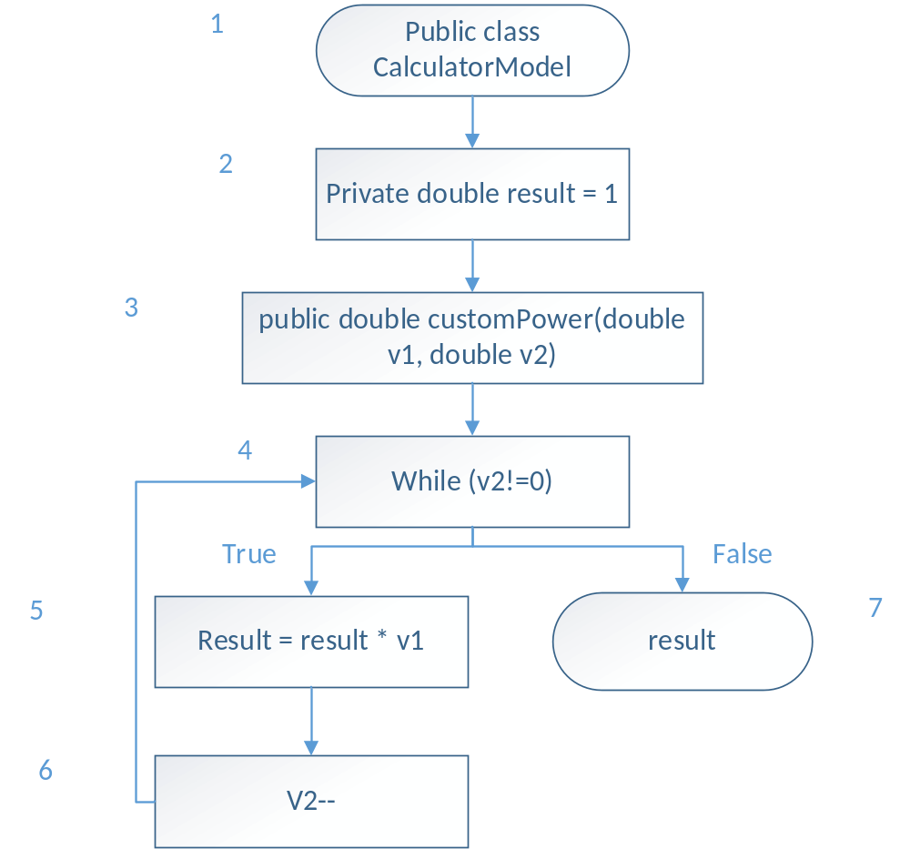
Minimum number of test cases = e – n + 2 = 7 – 7 + 2 = 2
Test Cases: {<1,2,3,4,7>, <1,2,3,4,5,6,7>}

1.3.2 Functional testing
- Robust Worst-Case testing for square root function
We take one input variable for square root function.
So the number of test cases is: 7¹ = 7

Test cases | Description | Input | Expected output
1 | Min- | -1 | Out of range
2 | Min | 0 | 0
3 | Min+ | 2 | 1.4142135623730951
4 | Nom | 3025 | 55
5 | Max- | 99999999999998 | 9999999.9999999
6 | Max | 99999999999999 | 9999999.99999995
7 | Max+ | 100000000000000 | Out of range

2Testing Results

2.1 Test Cases for Method1
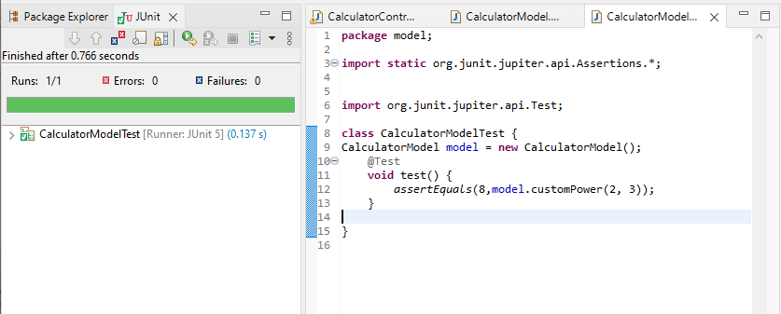
ID | Description | Input | Expected Output | Output | Result
201 | Check the power of 2^3 | (2,3) | 8 | 8 | Successful
202 | Check the power of (-2)^3 | (-2,3) | -8 | -8 | Successful

2.2 Test Cases for Method2

ID | Description | Input | Expected Output | Output | Result
101 | Check the result when square root for 9 has been given | 9 | 3 | 3 | Pass
102 | Check the result when square root of 12 has been given | 12 | 3.464106151377544 | 3.464106151377544 | Pass

2.3 Test Cases for Method2
ID | Description | Input | Expected Output | Output | Result
301 | Check the value of 5! | 5 | 120 | 120 | Successful
302 | Check the value of 2! | 2 | 2 | 2 | Successful

3 Results Analysis and Suggestions.
For bugs that have been identified by testing cases, you need to provide the analysis of the bugs and the suggestions to improve the quality of the program.

If no bugs are found by the test cases, does it means that your program is free of bug? Through what kind of approach, we can uncover bugs that have not been found yet.

